Contents

How to Install Git? 1

How to configure GIT ? 3

# How to Install Git?

Step 1 :

<https://git-scm.com/download/win>

Go to the above link and download the latest version as per the OS.

Step 2:

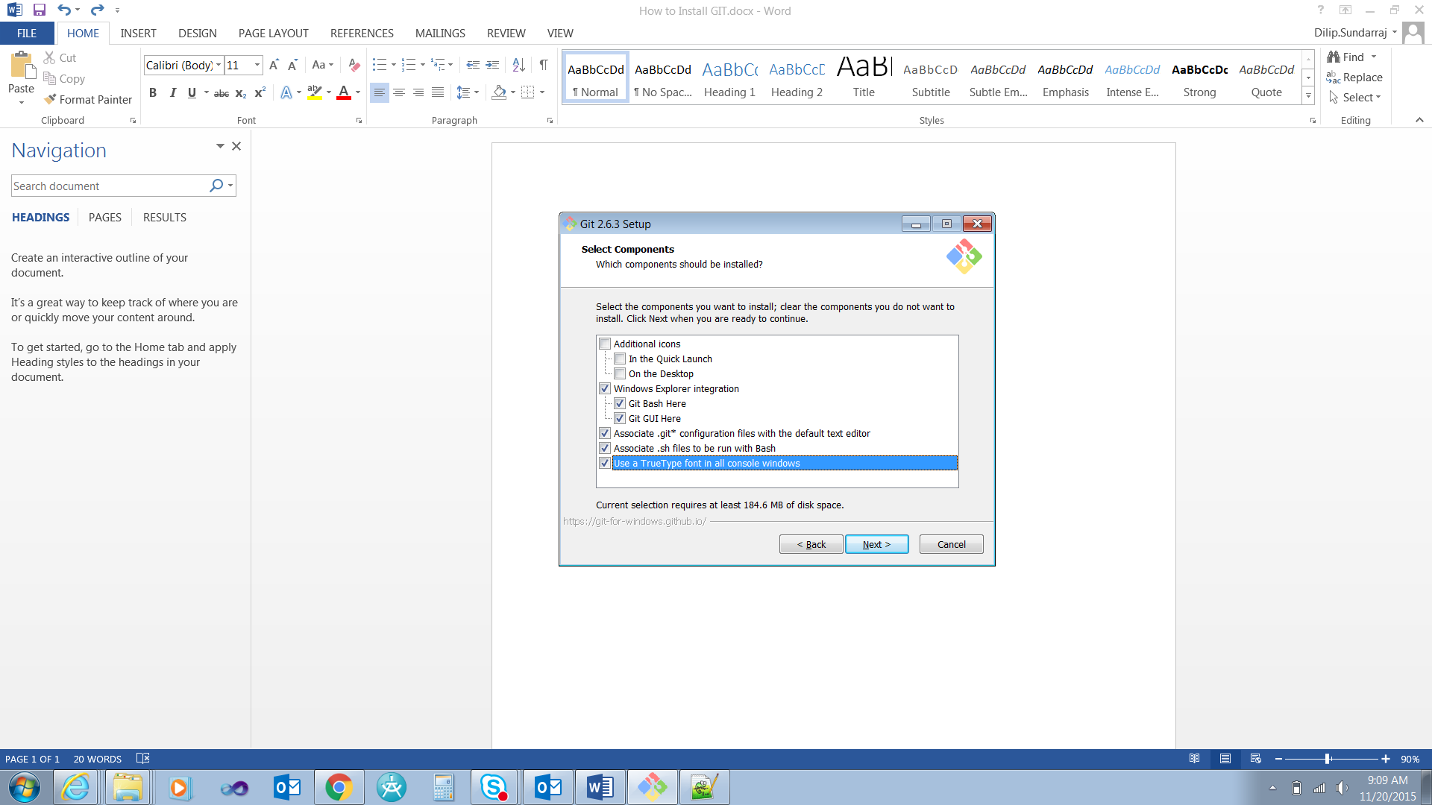

Step 3:



Step 4:



# How to configure GIT ?

**To set the user name for the GIT globally:**

DHC+Z001QGD@2QBZP12 MINGW64 /c/Dilip/Study/GIT (master)

$ git config --global user.name "Dilip Sundarraj"

$ git config --global –list:

This is used to list global variables for GIT in the system.

DHC+Z001QGD@2QBZP12 MINGW64 /c/Dilip/Study/GIT (master)

$ git config --global --list

user.name=Dilip Sundarraj

**To set the email:**

DHC+Z001QGD@2QBZP12 MINGW64 /c/Dilip/Study/GIT (master)

$ git config --global user.email [dilip.thelip@gmail.com](mailto:dilip.thelip@gmail.com)

**Auto** **Correct**:

The below command actually auto corrects if you mistype something.

It waits for one tenth of a second and auto corrects it. As per the below command it waits for 0.1 seconds and auto corrects it.

DHC+Z001QGD@2QBZP12 MINGW64 /c/Dilip/Study/GIT (master)

$ git config --global help.autocorrect 1

Eg.,

We mistyped statsu but it waited for 0.1 seconds and auto corrects it.

$ git statsu

WARNING: You called a Git command named 'statsu', which does not exist.

Continuing under the assumption that you meant 'status'

in 0.1 seconds automatically...

On branch master

Initial commit

Untracked files:

(use "git add <file>..." to include in what will be committed)

How to Install GIT.docx

~$w to Install GIT.docx

nothing added to commit but untracked files present (use "git add" to track)

**Color.ui:**

DHC+Z001QGD@2QBZP12 MINGW64 /c/Dilip/Study/GIT (master)

$ git config --global color.ui auto

**Crlf : (Carriage return line feed)**

**Read this is in GIt document.**

**For windows it is preferred to set it as true.**

**For Mac and Unix it is preferred to set it as false.**

DHC+Z001QGD@2QBZP12 MINGW64 /c/Dilip/Study/GIT (master)

$ git config --global core.autocrlf true

**To display the config:**

cat .git/config

vim .git/config

# How to create Files ?

echo “Hello Again”> Readme.txt -> This will create the Readme.txt file with the Hello Again

touch file1.txt file2.txt -> This command creates two files.

## How to unset the configurations ?

Git config –unset user.name -> This command unsets the configuration variable from the configuration list.

# How to create a Repository ?

DHC+Z001QGD@2QBZP12 MINGW64 /c/Dilip/Study/GIT (master)

$ git init

# How to Track the file changes?

Git status -> this command will tell you what are the untracked files in the repository.

Untracked files:

This tells the files mentioned are not in the repository and the files are not tracked by Git.

$ git status

On branch master

Initial commit

Untracked files:

(use "git add <file>..." to include in what will be committed)

How to Install GIT.docx

README.txt

~$w to Install GIT.docx

~WRL1961.tmp

nothing added to commit but untracked files present (use "git add" to track)

# How to add a file to the Git Repository ?

$ git add README.txt

# How to add the updated files ?

git add -u

# How to commit the file to the repository ?

$ git commit -m 'added readme'

# How to check the history of changes ?

$ git log

commit 405ea2a3d6e2202194c15a910539876af48be7e9

Author: Dilip.Sundarraj <dilip.thelip@gmail.com>

Date: Fri Nov 20 13:33:32 2015 -0600

added readme

# What is HEAD ?

The latest commit is known as HEAD.

Head~1 -> This is the version is the prior to the latest commit.

# How to check the differences between the different commited version ?

HEAD -> This is the latest committed version

DHC+Z001QGD@2QBZP12 MINGW64 /c/Dilip/Study/GIT (master)

$ git diff HEAD~1..HEAD

# How to remove files using Git ?

DHC+Z001QGD@2QBZP12 MINGW64 /c/Dilip/Study/GIT (master)

$ rm file2.txt

# How to Rename File names?

DHC+Z001QGD@2QBZP12 MINGW64 /c/Dilip/Study/GIT (master)

$ mv file file_updated.txt

# Commands:

Cat:

Cat command is used to read one or more files and display it in the standard output.